**Day-7 Assignment**

**Analysing the Data and finding reason of Attrition and ways to minimize Attrition**

1. **Analysing Total number of People who left from whole data**

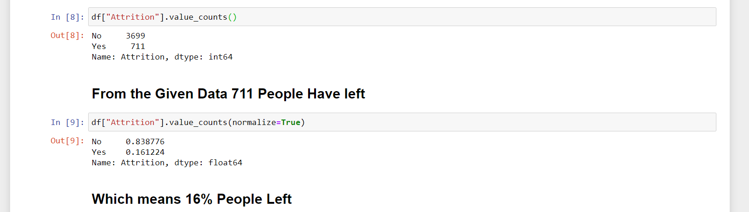

1. **There is 62% Male Attrition and 37% Female Attrition**

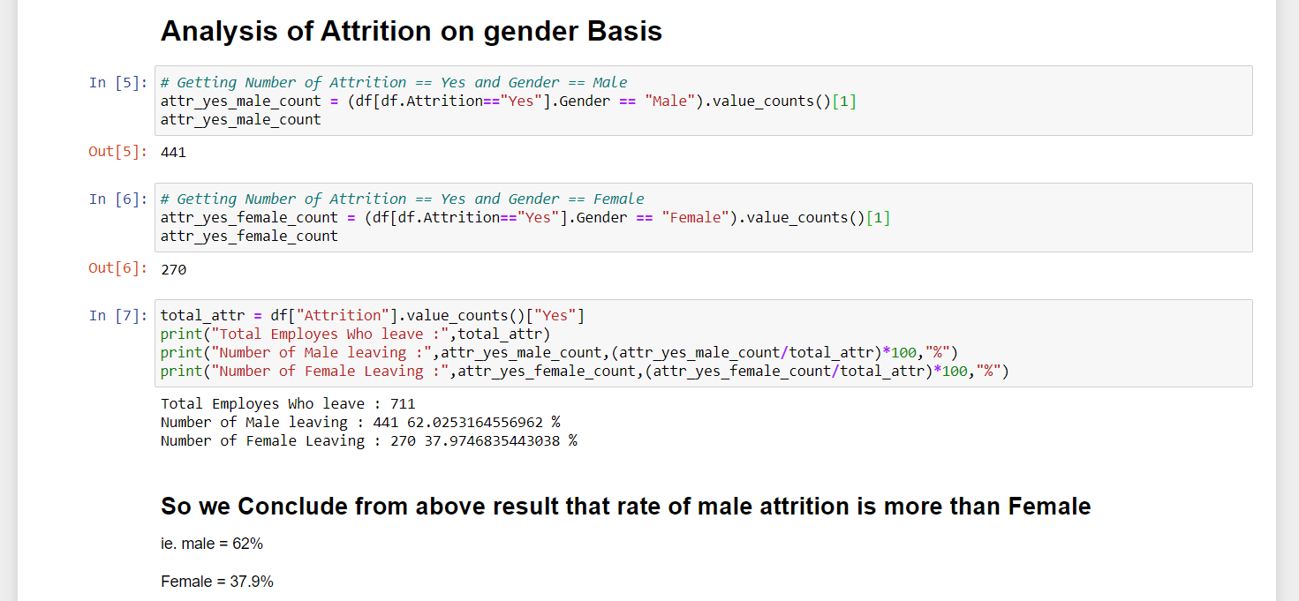

1. **Analysis Based on Marital Status of Employees**

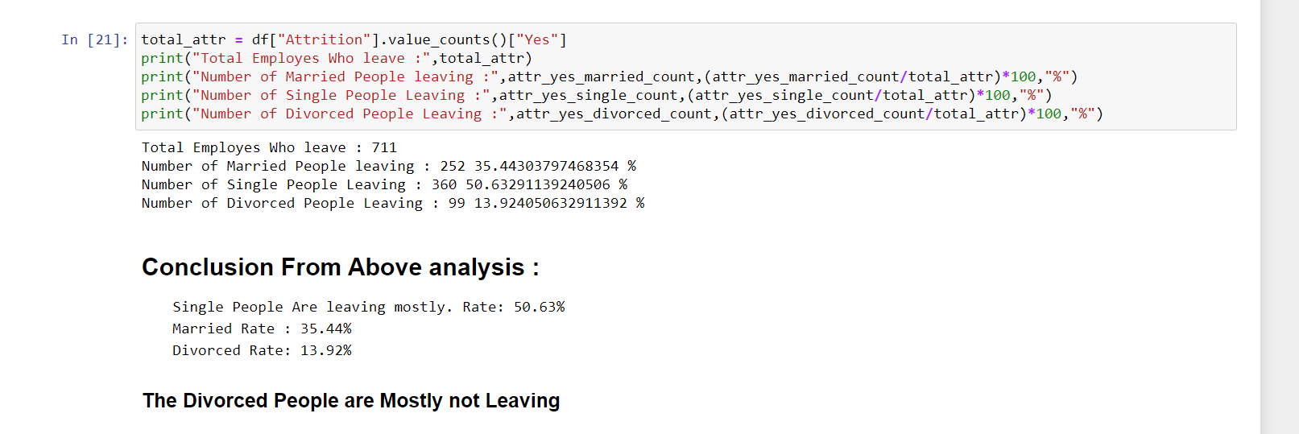

1. **Analysis based on PercentSalaryHike**

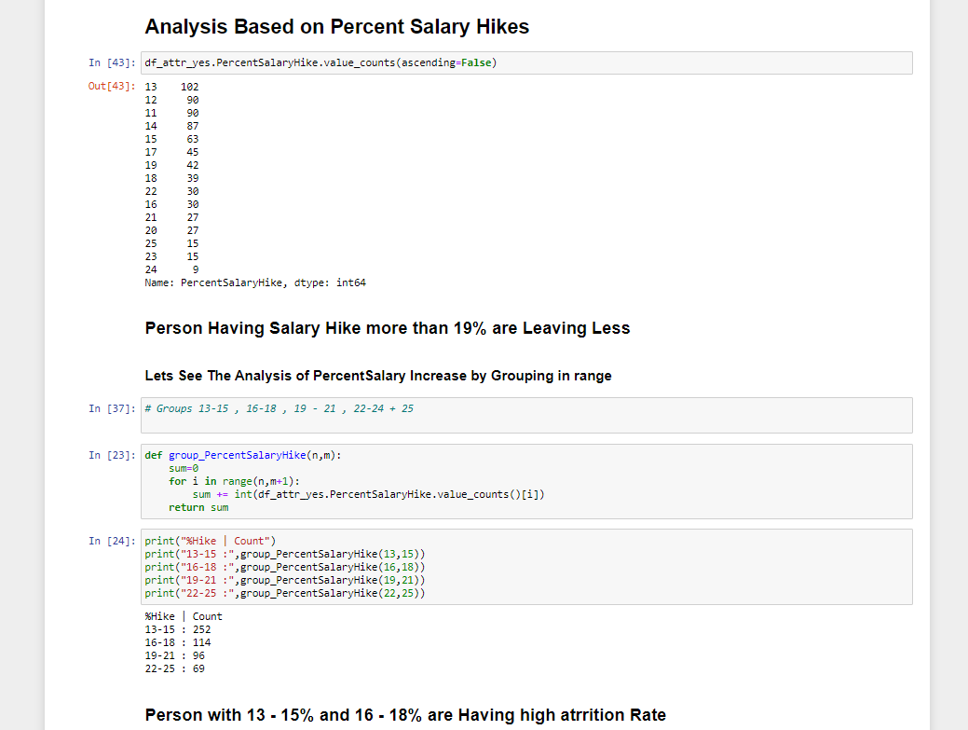

1. **Analysis based on Age**

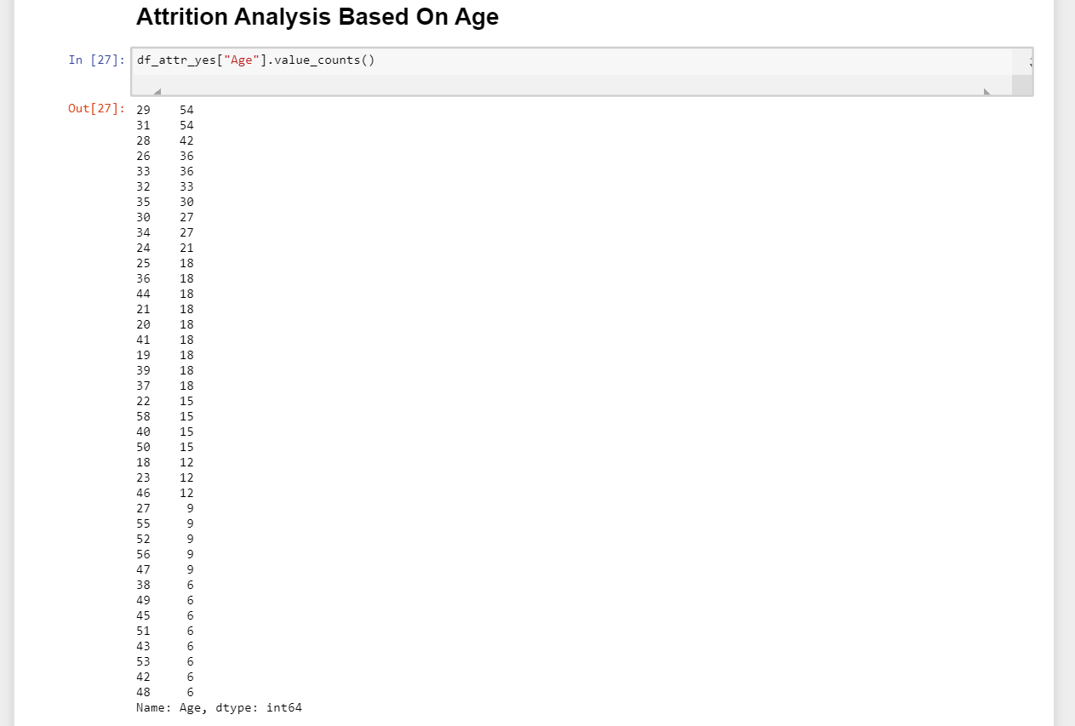

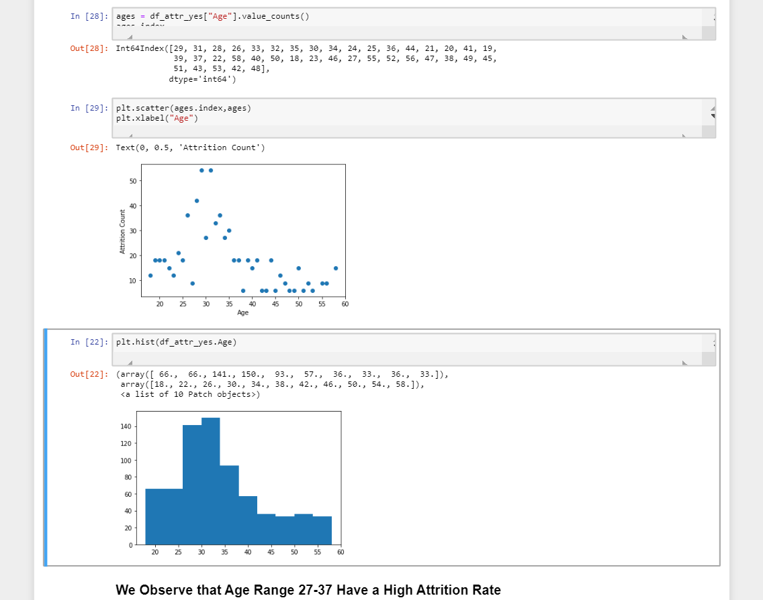

1. **Analysis Department wise**

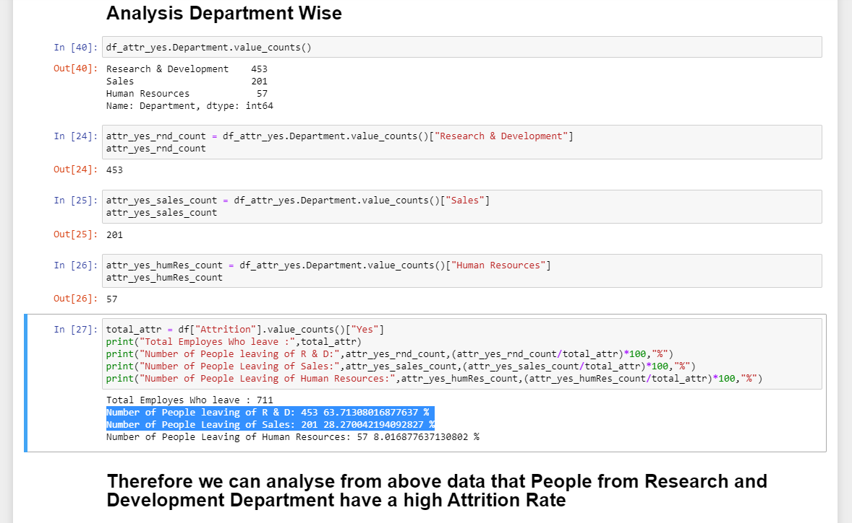

1. **Analysis Based On Job-Role**

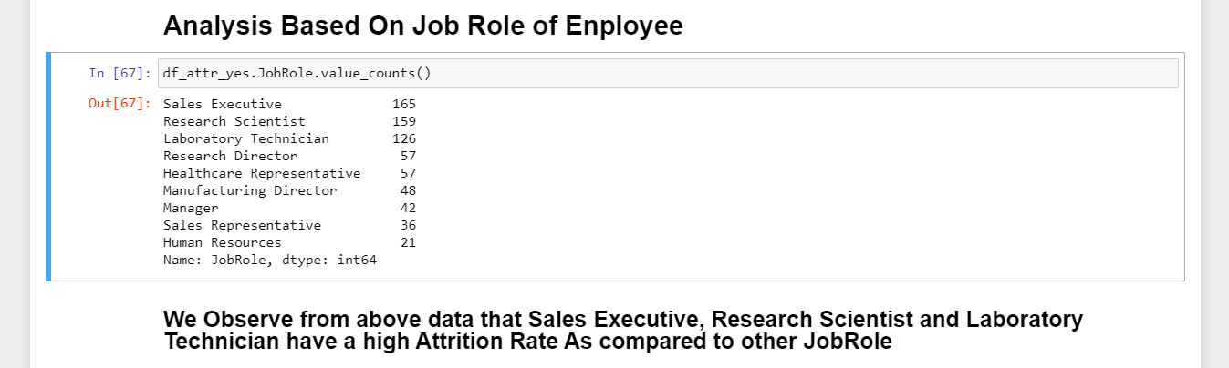

1. **Analysis Based on Years at Company**

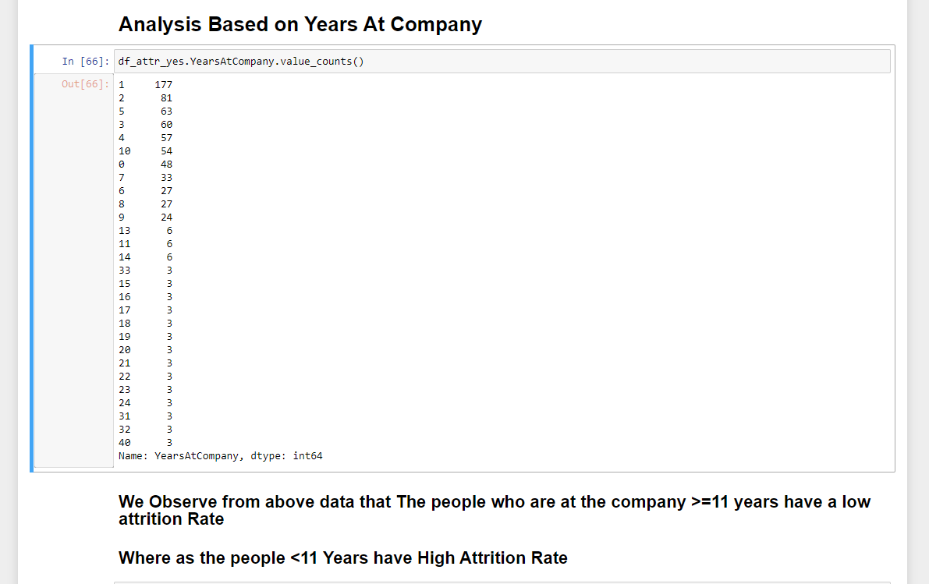

1. **Analysis Based On Education Field of the Employee**

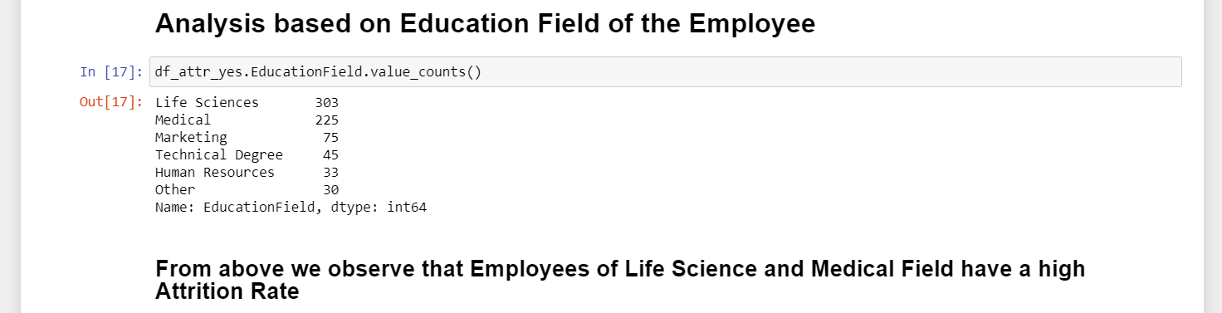

**10.) Analysis Based on total work Experience of Employees**

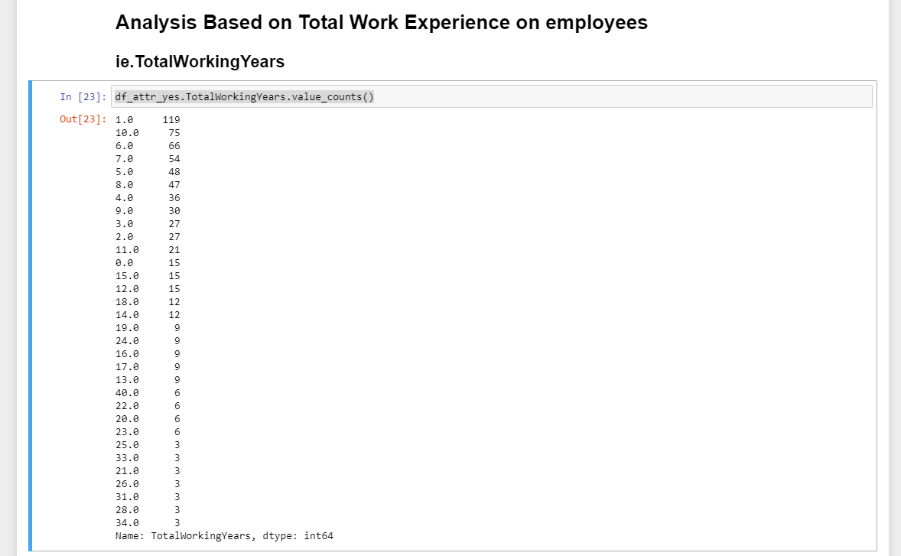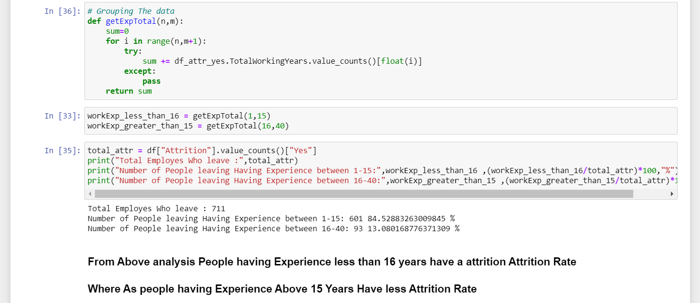

**Summarizing the Analysis**

**1 ) Male Attrition is more than the Females**, So a survey regarding the issues faced by Males in the organization could help the organization to reduce Male Attrition

**2 ) Less PercentSalaryHike** given to the employees may be one on the reasons too so Salary hikes can be given.

**3) People of age 27-37 have a high attrition rate**, so the Salary hikes can be granted to this Age-range people.

**4) R & D Department People have a high Attrition Rate,** a survey regarding the issues faced by the R&D Dept. People can help to know problem in that Department.

**5) The Sales Executives, Research Scientists and Laboratory Technician Have a high Attrition Rate,** So the survey for the people of this job- Roles can help to know about the issues.

**6)**  **The People who are with the company less than 11 Years have a high attrition rate.**

**7)**  **The People having total Experience less than 16 years have a high Attrition rate**, so for these kind of people some interesting activities can be conducted.

Mostly the young Employees who have less experience are leaving, so a reason might be their like they might be not getting the chance to work on what technology they like, so a survey for the young employees can be conducted and the company can put employees on the technologies which they like.

This Solution might help reduce the Attrition rate of young Employees.